Exam Guide:

<https://youtu.be/tE0CvLjcZQ8?feature=shared>-important

Sample questions:

<https://interview.quicktechie.com/certifications/details/16/Certified-Generative-AI-Engineer-Associate> --important

<https://www.databricks.com/sites/default/files/2024-05/Databricks-Exam-Guide-Generative-AI-Engineer-Associate-Exam-Guide.pdf> -important register with your personal mail ids for free preview of one sample pamper

<https://www.databricks.com/sites/default/files/2024-05/Databricks-Exam-Guide-Generative-AI-Engineer-Associate-Exam-Guide.pdf>

<https://www.examtopics.com/exams/databricks/certified-generative-ai-engineer-associate/view/>

<https://www.youtube.com/watch?v=YK31MvgI7gc> ---important

<https://www.youtube.com/watch?v=FRh5YZ7vxXg>

<https://www.youtube.com/watch?v=oy4Uz90D188>

<https://www.youtube.com/watch?v=ea104c-XHpA>

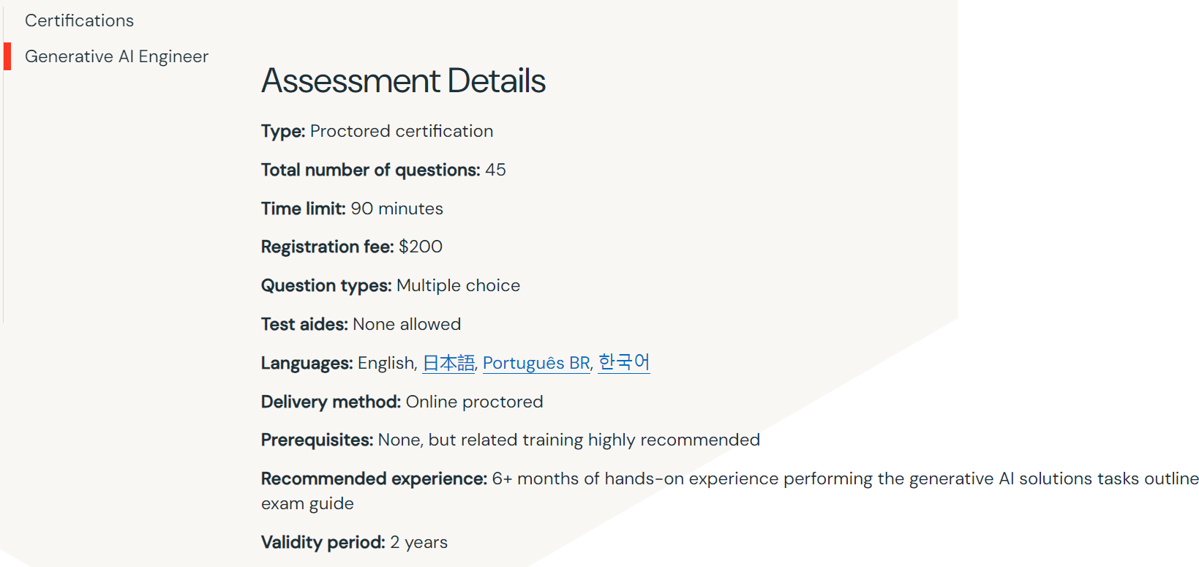

LAMA

vector

DBembeddings  
 Langchain  
 pyspark  
 different LLM Embeddings  
 Python - implementation   
 model Hallucination

mistral